# Spaceship Crafting

*SpamFire wants to build a spaceship and start travelling through the galaxy. He must find some cores, which convert into bars and mix with other bars to build a specific spaceship depending on the bars count.*

You will be given a **sequence** of **5 integers**. The first **4** **integers** represent the **found** **cores** for each type:

* Titanium **core**
* Aluminum **core**
* Magnesium **core**
* Carbon **core**

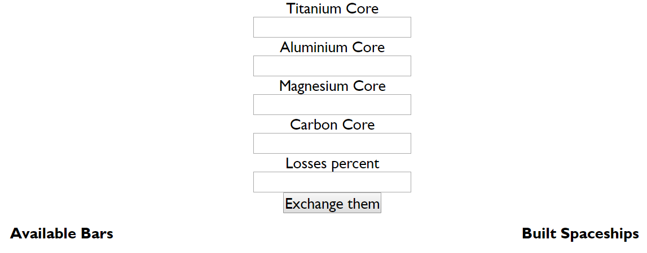

After finding these **cores**, he returns to his workshop, but on his way back he **loses** part of the found **cores**. The **last** **integer** you receive from the input represents **the** **lost cores** in **percentage**. He packed the cores in such way, that the **losses** for each **type** of **core** are the **same**. This means you must **split** the **percentage** **equally** for each **type** of **core** and **decrease** the **quantity** by the **split percentage**.

Here's some black-market information, about the rate at which you can **convert** your **cores** to real **material bar**.

|  |  |
| --- | --- |
| **Product** | **Price** |
| 1 Titanium **bar** | 25 **Core** |
| 1 Aluminum **bar** | 50 **Core** |
| 1 Magnesium **bar** | 75 **Core** |
| 1 Carbon **bar** | 100 **Core** |

After SpamFire **converts** his **cores** into **bars** you must help him choose a **spaceship**, depending on the **available** **bars**. Consider that SpamFire **continues** **building** **spaceships** until he's out of bars**.**

**SpamFire tries to build ships from the** **most** **expensive to the cheapest one and repeats it over and over until his materials are insufficient.**

Here's the list with the spaceships that SpamFire can **build** with **his** **bars**.

|  |  |
| --- | --- |
| **Spaceship** | **Needed materials** |
| The-Undefined-Ship | 7 titanium **bars**, 9 aluminum **bars**, 7 magnesium **bars**, 7 carbon **bars** |
| Null-Master | 5 titanium **bars**, 7 aluminum **bars**, 7 magnesium **bars**, 5 carbon **bars** |
| JSON-Crew | 3 titanium **bars**, 5 aluminum **bars**, 5 magnesium **bars**, 2 carbon **bars** |
| False-Fleet | 2 titanium **bars**, 2 aluminum **bars**, 3 magnesium **bars**, 1 carbon **bar** |

### Input

* The **first 4 integers** represent the **found** **cores** for each type (Titanium core, Aluminum core, Magnesium core and Carbon core)
* **The last integer** (the 5th one) is the **percentage** of **losses** on all **found** **cores**
* All incoming information comes from **5 input fields**  
  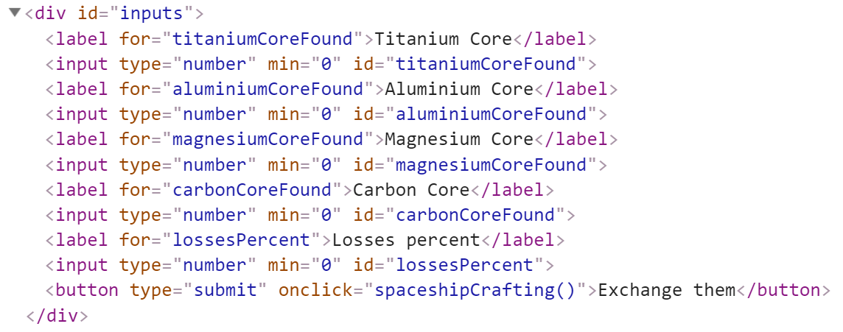

### Output

* Output contains **two strings**
  + The first one is **all** **built** **spaceships** in format:

`{count} THE-UNDEFINED-SHIP, {count} NULL-MASTER, {count} JSON-CREW, {count} FALSE-FLEET`- Print only the spaceships that are built at least **once**.

* + The second one is all available materials in format:  
    `**{count} titanium bars, {count} aluminum bars, {count} magnesium bars, {count} carbon bars`;**
* Output strings must be set like **text content** in the following elements:  
  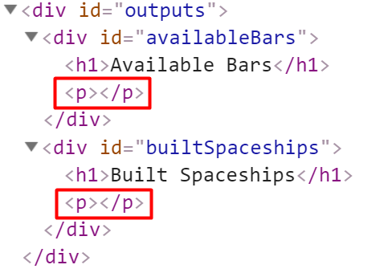

### Constraints

* The incoming integers will be **greater than** or **equal to** **0**
* The quantity of each **found** **core** must be **rounded** to the **closest** **integer**
* SpamFire can build **more** **than** **1** spaceship
* Print only the **spaceships** that are built at least **once**

### Examples

|  |  |
| --- | --- |
| ****Input**** | ****Output**** |
| **467.5, 1265, 1815, 1650, 40** | **1 THE-UNDEFINED-SHIP, 1 NULL-MASTER, 1 JSON-CREW, 1 FALSE-FLEET**  **0 titanium bars, 0 aluminum bars, 0 magnesium bars, 0 carbon bars** |
| **600, 1600, 2175, 2100, 0** | **1 THE-UNDEFINED-SHIP, 2 NULL-MASTER, 1 JSON-CREW, 1 FALSE-FLEET**  **2 titanium bars, 2 aluminum bars, 0 magnesium bars, 1 carbon bars** |

